Purchasing contract

Party A: Party B:

Name of Commodity | ODOO BPMN Workflow Package 2.0
Specifications | For odoo 17
amount of contract | USD: $6000.00
Service | maintenance for 12 months

In the above ODOO BPMN Workflow Package purchase contract
For Party A (here in after referred to as Party A), for Party B (here in after referred to as Party B), to Annex 2 The terms are within the contract.
The contract is two sides, the two sides signed and each hold a kept.
Annex: 1. Supply items and special terms
2. Contracts General terms

Annex 1

Supply items
1. Supply itmes:
ODOO BPMN Workflow Package 2.0 for odoo 17
ODOO BPMN Workflow Package 2.0 include:
- just_todo: for workflow task executor to do tasks or approve
- just_widget_colorpicker: for workflow node and trans set color and board
- just_workflow_bpmn,: using bmpn.io for the diagramming part,
- just_workflow_engine: A custom development, for Drive Workflow Execution,
- Just_widget_condition: Assist in generating custom conditional expressions(only for odoo17)
- Just_digital_sign:Digital signatures in process reviews(only for odoo16,17)
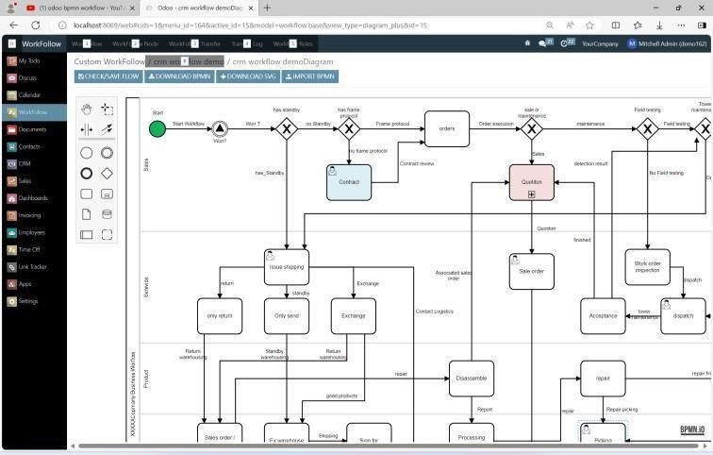

Annex 2

General Conditions of contract

General provisions

Objectives of the contract
This contract stipulates that "software and hardware products and related services shall be provided by party "B" and accept the rights and obligations of both parties arising from the requirements of Party A. Both parties should conscientiously perform this contract under the principle of mutual trust.

Definition and scope
(1).Supply item
The official version of odoo bpmn workflow package provided by party B with source code.
(2).Maintenance: The following items for the items supplied
    - Software modification or functional changes as well as when the user needs to be collectively usage training;
    - When the software function finds a fault during use, it needs to be maintained;

Contract and Contract Content

the establishment of the contract
Party A and Party B sign the contract, and this contract is established after Party A has paid the payment to Party B. In the case where the contract is not established, the schedule in the contract will be automatically postponed until the contract is established.

Payment
Party A may choose one of the following convenient ways to pay for contract.

USD$
Bank name: Citibank
Bank address: 111 Wall Street New York, NY 10043 USA
Routing (ABA): 031100209 SWIFTcode: CITIUS33
Account number: Accounttype: CHECKING Beneficiary name:
EUR€
Bank name: Banking Circle S.A.
Bank address: 2, Boulevard de la Foire L-1528 LUXEMBOURG
IBAN:
BIC: BCIRLULL
Beneficiary name:

Deliver
Party B shall supply Party A with all the addons package with source code after Receive payment.
Unique received (email / skype):
The source code and the upgrade package sent according to the specified unique received. Changing the unique received during the contract period requires the written approval of both parties.

service range
The scope of business entrusted by Party A to Party B is as follows:
- Installation guidance of software products provided by Party B for free.
- User training of software products provided by Party B for free.
- The maintenance such as bug fixing, function upgrade of the software products provided by Party B for free.
- Functioncustomization, thecharges will be negotiated withanother separate contract.

Warranty and maintenance

Warranty
- Party B is responsible for the warranty of the faults found within 12 months from the acceptance of the final delivery product.
- When Party A requests a warranty for the products supplied to Party B, Party B shall notify Party A of the solution within 48 hours upon notice, and shall do its best to carry out the warranty.

Paid maintenance contract
After the end of the free maintenance period, in order to ensure the continuous and effective operation of the system, both parties can sign a separate maintenance contract.

Other Additional matters

Confidentiality matters
- The information of the other company and business directly or indirectly obtained by Party A and Party B during the software implementation process shall not be disclosed to any third party.
- If the other party has caused a loss due to the mistake of either party, it shall respond to the other party's claim for compensation.

Data and data management
- Party B shall be responsible for the safety management of Party A's data during the course of business.
- All information provided by Party A in the business shall be returned in principle.
- The management responsibility of the data entered by Party A in the software provided by Party B is ultimately in Party A.

Rights and obligations and transfer
Party A and Party B shall not transfer all or part of the rights and obligations specified Party A may release the purchased component package with the application, but is not allowed to directly resell or sell or diffuse the component package that in this purchased contract.

Termination and automatic termination of the contract
When the following events occur,the contract between Party A and Party B may cancel part or all of the contents,and the reason shall be notified to the other party in writing.
- If Party B fails to perform the relevant obligations in the contract during the contract period without justifiable reasons;
- If Party A has no valid reason to violate the relevant provisions of the settlement method in the contract;

Arbitration department
When a dispute arises between the two parties in the contract, the affiliated arbitration department shall take the court of the locality of Party A as the first.

Agreement
Both Party A and Party Bcarefully readthiscontractandconfirmedthat itwas correct and there was no objection.

Party A: Party B:

Signature (under seal): Signature (under seal):

Date: Date:

Annex Sale Order

Sales Order -

Sale Information Invoicing & Shipping Address
Order Date:
Expiration Date:

Untaxed Amount Tax
Total

Terms & Conditions

Payment terms
Payment terms:

